SkillSprint AI
Project Report

Client Company: NovaCart - E-Commerce & Logistics Marketplace
Aptech TechWiz 7 - Generative AI PowerPlay
September 28, 2026
Table of Contents

Chapter 1: Introduction 3
1.1 Problem Definition 3
1.2 Background 3
1.3 Proposed Solution 3
1.4 Purpose 4
Chapter 2: Requirements & System Scope 4
2.1 Scope 4
2.2 Constraints 4
2.3 Functional Requirements 5
2.4 Non-Functional Requirements 5
Chapter 3: System Architecture & Design 6
3.1 System Architecture 6
3.2 Module Descriptions 6
3.3 Database Design 8
3.4 DFD - Data Flow Diagram 8
3.5 Use Case Diagram 10
3.6 Activity Diagram 11
3.7 Sequence Diagram 14
Chapter 4: Document Processing & Role Matrix 15
4.1 Document Processing Pipeline 15
4.2 Document Chunking 16
4.3 Role Requirement Matrix 17
Chapter 5: GenAI Pipeline 17
5.1 Prompt Design and Versions 17
5.2 GenAI Model / API 18
5.3 JSON Schema 18
Chapter 6: Python Validation Pipeline 19
6.1 Validation Pipeline 19
6.2 Coverage Validation 20
6.3 Traceability Validation 20
6.4 Hallucination Detection 21
6.5 Contradiction Detection 21
6.6 Prompt Injection Detection / Defense 22
6.7 GenAI vs Python Comparison 22
Chapter 7: Security & Reliability 22
7.1 Security 22
Chapter 8: Testing & Evaluation 23
8.1 Testing 23
Chapter 9: Limitations & Future Work 24
9.1 Limitations 24
9.2 Future Work 24

Chapter 1: Introduction

1.1 Problem Definition
Enterprise employee onboarding in complex operational domains suffers from critical fragmentation, cognitive overload, and policy drift. In organisations like NovaCart - a multi-departmental e-commerce and logistics firm operating warehouse fulfillment, real-time payment processing, and high-concurrency cloud engineering - new hires face tens of disconnected compliance handbooks, SOPs, and departmental memos.
Existing corporate practices suffer from three failure modes:
- The "Day-1 Firehose": Employees receive all policies simultaneously regardless of urgency, leading to superficial skimming of life-critical safety rules or regulatory compliance standards.
- Generic, One-Size-Fits-All Training: Engineers are subjected to redundant accounting overviews, while customer support staff receive inadequate instruction on escalating payment disputes.
- Policy Drift and Silent Hallucinations: Outdated procedures persist in team FAQs, causing new hires to follow obsolete rules that directly contradict updated company policies. When legacy AI tools are applied, they routinely hallucinate plausible-sounding procedures that have no backing in authoritative documentation.

1.2 Background
Traditional Learning Management Systems (LMS) act as static document repositories. They lack the intelligence to synthesize disparate operational documents into coherent, sequential learning pathways tailored to specific job titles, seniority levels, and department functions.
Recent advances in Large Language Models (LLMs) enable contextual text generation and instructional design, but commercial GenAI models present severe risks when deployed naively:
- Unverified Hallucinations: Fabricating company benefits or security protocols.
- Instruction Injection: Malicious or accidental prompt overrides embedded in uploaded PDF files.
- Opacity: Inability to prove that 100% of mandatory regulatory requirements are satisfied prior to employee certification.
SkillSprint AI was built to close this trust gap by keeping generation separate from validation.

1.3 Proposed Solution
SkillSprint AI introduces a Dual-Pipeline Architecture:
- Pipeline 1 (GenAI Synthesis & Enrichment): Ingests approved company knowledge, parses layout structure, maps against an authoritative Role Requirement Matrix, and queries an LLM through Command Code (default model deepseek/deepseek-v4-flash-fast) via versioned prompt templates to generate staged learning plans, contextual tasks, scenario challenges, and quizzes constrained strictly to typed Pydantic JSON contracts.
- Pipeline 2 (Deterministic Pure-Python Validation Engine): An independent, pure-Python engine executing 9 deterministic validators. Pipeline 2 imports zero GenAI dependencies. It audits the generated plan for:
  - 100% Mandatory Requirement Coverage.
  - Exact source traceability back to approved document section IDs.
  - Cross-document contradiction resolution via an external policy precedence hierarchy.
  - Elimination of adversarial prompt-injection vectors and hallucinated facts.
  - Multi-stage learning progression (enforcing basic before advanced concepts).
Generated items meeting all criteria are marked Verified; items with ambiguities or detected conflicts are automatically routed to a Human-in-the-Loop Review Queue.

1.4 Purpose
The purpose of SkillSprint AI is to provide NovaCart with a verifiably grounded, audit-ready onboarding platform that guarantees regulatory compliance, accelerates time-to-productivity for new hires across 10 operational roles, and provides training managers and reviewers with total visibility and override authority over AI-generated learning materials.

Chapter 2: Requirements & System Scope

2.1 Scope

In-Scope Functional Capabilities
- Automated ingestion, parsing, chunking, and version tracking of PDF and DOCX documentation.
- Role Requirement Matrix management across 10 distinct job roles and 178 regulatory/operational clauses.
- Structured onboarding plan generation across 6 canonical stages (Day 1, Week 1, Week 2, First 30 Days, First 60 Days, First 90 Days).
- Pure-Python deterministic verification pipeline executing 9 concrete validation checks.
- Requirement-level comparison engine auditing ≥100 requirements between Python expectations and GenAI results.
- Human-in-the-loop triage queue with reviewer override, approval, rejection, and full audit logging.
- Role, Admin, and Employee interactive web dashboards with progress tracking, adaptive recommendations, and weak-area identification.
- Policy update detection with automated impact analysis and selective plan regeneration.
- Multi-format report export (CSV, Excel .xlsx, PDF).

Explicit Out-of-Scope Statement (SRS Section 1.5)
The following enterprise capabilities are formally out of scope for this competition release:
- Live Human Resource Management System (HRMS) database synchronization.
- Live corporate payroll and compensation processing.
- Enterprise single-sign-on (SSO) identity federation (Active Directory / Okta / SAML / OIDC).
- Commercial Learning Management System (LMS) SCORM package hosting.

2.2 Constraints
- Pipeline 2 Independence Constraint: The validation package must not import or invoke any GenAI API or LLM SDK. Validation must remain 100% deterministic and reproducible in standard Python.
- No Hard-Coded Output Constraint: Validation scores, plans, quiz answers, and comparison outputs must be dynamically computed from data files, database records, and active schemas.
- Structured JSON Output Constraint: GenAI output must adhere strictly to predefined Pydantic schemas. Unstructured, free-form prose is never accepted as the plan of record.
- Execution Time Budget: The target end-to-end budget for plan generation and validation is 30 seconds. With the current model provider the measured time is about 37 seconds, because validation takes only milliseconds and almost all of the time is spent waiting for the model.
- Security & Zero Secrets: API keys and credential tokens must be supplied strictly via environment variables (COMMAND_CODE_API_KEY) and never committed to source control.

2.3 Functional Requirements
The platform implements all 66 Functional Requirements specified in the SRS. The table below groups them by area. All 66 are implemented.
Area (requirement IDs) | Covers | Status
Users and roles (FR-01 to FR-04) | Authentication, role-based access control, employee profiles, role management | IMPLEMENTED
Document management (FR-05 to FR-10) | Upload, validation, parsing, chunking, source metadata, version control | IMPLEMENTED
Requirements (FR-11, FR-12) | Requirement extraction and the Role Requirement Matrix | IMPLEMENTED
GenAI integration (FR-13 to FR-16) | API integration, prompt templates, structured JSON output, schema validation | IMPLEMENTED
Plan generation (FR-17 to FR-27) | Personalized multi-stage plans, modules, objectives, checklists, tasks, scenarios, quizzes, assessments, rubrics | IMPLEMENTED
Sequencing and coverage (FR-28 to FR-34) | Prerequisites, sequence validation, source citation, validation pipeline, coverage and traceability scores | IMPLEMENTED
Quality checks (FR-35 to FR-39) | Hallucination detection, contradiction detection, policy precedence, duplicate detection, role relevance | IMPLEMENTED
Comparison (FR-40 to FR-43) | Consistency testing, GenAI/Python comparison, verification status | IMPLEMENTED
Human review (FR-44 to FR-47) | Review queue, reviewer decisions, overrides, audit trail | IMPLEMENTED
Injection defense (FR-48, FR-49) | Prompt injection protection and adversarial document detection | IMPLEMENTED
Dashboards (FR-50 to FR-56) | Employee, admin and role dashboards, progress tracking, weak areas, adaptive recommendations | IMPLEMENTED
Policy updates (FR-57 to FR-59) | Update detection, impact analysis, selective regeneration | IMPLEMENTED
Search and reports (FR-60 to FR-62) | Search and filtering, reports, CSV / Excel / PDF export | IMPLEMENTED
Platform (FR-63 to FR-66) | Error handling, retry management, model and prompt logging, responsive web interface | IMPLEMENTED

2.4 Non-Functional Requirements
ID & Requirement | Target Metric | Measured Result in Repo | Status
NF-01 Performance | End-to-end plan generation + validation ≤ 30.0 s | About 41 seconds or less. | PARTIAL
NF-02 Scalability | Support 1,000 employees, 100 roles, 1,000 documents | NOT MEASURED (Schema indexed, DB ORM PostgreSQL-ready; automated benchmark not in repo) | PARTIAL
NF-03 Usability | Responsive desktop, tablet, mobile layouts; zero-clutter navigation | Clean responsive Bootstrap 5.3 UI templates with role navigation bars | IMPLEMENTED
NF-04 Accuracy & Grounding | 100% Mandatory requirement coverage prior to approval; valid source citations | Coverage: 100.0%, Traceability: 100.0% | IMPLEMENTED
NF-05 Availability | 99% platform uptime during evaluation window | NOT VERIFIABLE (Runtime hosting uptime requires multi-day deployment telemetry; /health probe available) | NOT VERIFIABLE

Chapter 3: System Architecture & Design

3.1 System Architecture
SkillSprint AI is architected as an 8-stage enterprise system that strictly bifurcates GenAI synthesis from deterministic Python verification.
Figure - D1 - System Architecture (8-Stage Flow)
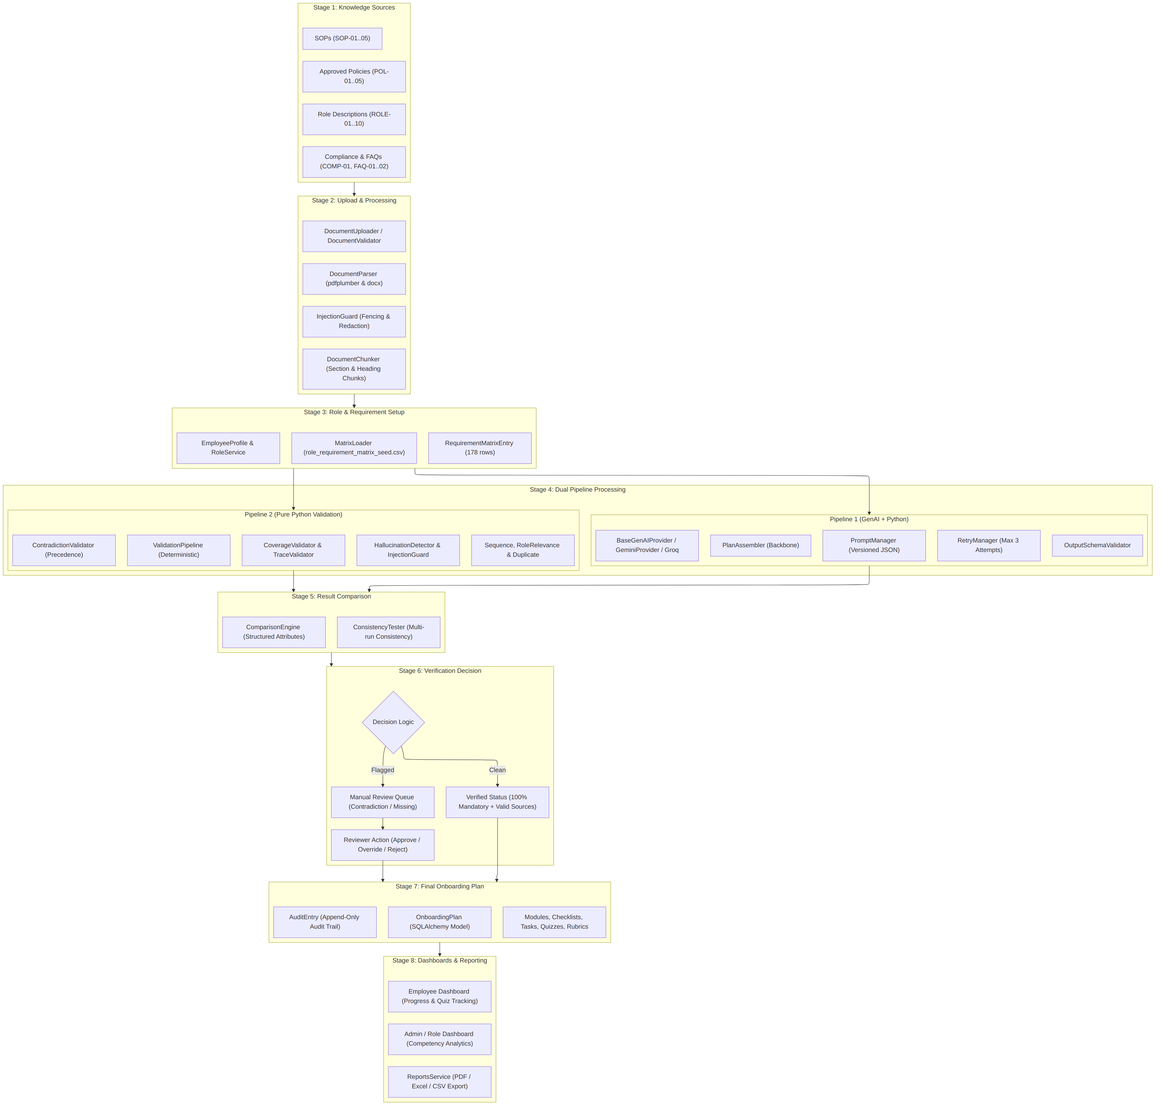

Architectural Explanation
The architecture implements the 8 stages defined by the TechWiz SRS. In Stage 1, raw company documents are ingested. In Stage 2, documents are parsed and fenced against prompt injections. Stage 3 structures requirements in a relational matrix. Stage 4 executes parallel pipelines: Pipeline 1 synthesizes structured learning items using GenAI, while Pipeline 2 evaluates compliance using pure Python rules. Stage 5 compares outputs on structured attributes, leading to the verification decision in Stage 6. Approved plans are persisted in Stage 7 and visualized via role dashboards in Stage 8.

3.2 Module Descriptions

1. document_processing/
- Responsibility: Ingestion, file validation, text parsing, structural chunking, and injection fencing of corporate documents.
- Key Classes: DocumentUploader, DocumentValidator, DocumentParser, DocumentChunker.

2. document_validation/
- Responsibility: Tracks document revisions, active vs superseded status, and effective date version transitions.
- Key Classes: DocumentVersionControl.

3. role_matrix/
- Responsibility: Loads, validates, and serves the 178-requirement matrix linking job roles to document sections.
- Key Classes: MatrixLoader, RoleMatrixService.

4. genai_pipeline/ (Pipeline 1)
- Responsibility: Deterministic plan assembly, external prompt template management, LLM provider invocation (Command Code), retry backoff, and Pydantic schema validation.
- Key Classes: PlanAssembler, PlanGenerator, CommandCodeProvider, RetryManager, OutputSchemaValidator.

5. python_validation/ (Pipeline 2)
- Responsibility: 100% deterministic pure-Python compliance verification across 9 concrete validators without any GenAI calls.
- Key Classes: ValidationPipeline, CoverageValidator, TraceabilityValidator, SequenceValidator, DuplicateValidator, RoleRelevanceValidator.

6. comparison_engine/
- Responsibility: Performs requirement-level comparisons between Python expectations and GenAI results on structured attributes; evaluates multi-run generation consistency.
- Key Classes: ComparisonEngine, ConsistencyTester.

7. contradiction_checks/
- Responsibility: Detects conflicts across 10 canonical contradiction pairs in corporate policies and enforces precedence hierarchy.
- Key Classes: ContradictionValidator, resolve_precedence.

8. hallucination_checks/ & security/
- Responsibility: Scans for unsupported claims, raw injection containers, and 19 prompt-injection signatures.
- Key Classes: HallucinationDetector, InjectionGuard.

9. src/ (Web Application & Domain Services)
- Responsibility: REST endpoints, authentication/RBAC, review workflows, interactive dashboards, search, and reports.
- Key Subpackages:
  - src/auth/: User authentication, session management, RBAC dependencies.
  - src/dashboards/: Progress tracking, weak-area detection, adaptive recommendations.
  - src/plans/: Plan generation lifecycle, policy update impact analysis, selective regeneration.
  - src/reviews/: Review queue, decision records, reviewer overrides, append-only audit trail.
  - src/reports/: Executive metric summaries, CSV/Excel/PDF export.
  - src/search/: Full-text and metadata filtering across documents, plans, and matrix.

3.3 Database Design
The database schema is defined using SQLAlchemy ORM models supporting development on SQLite and easy migration to PostgreSQL.
Figure - D6 - Entity-Relationship Diagram (Database Design)
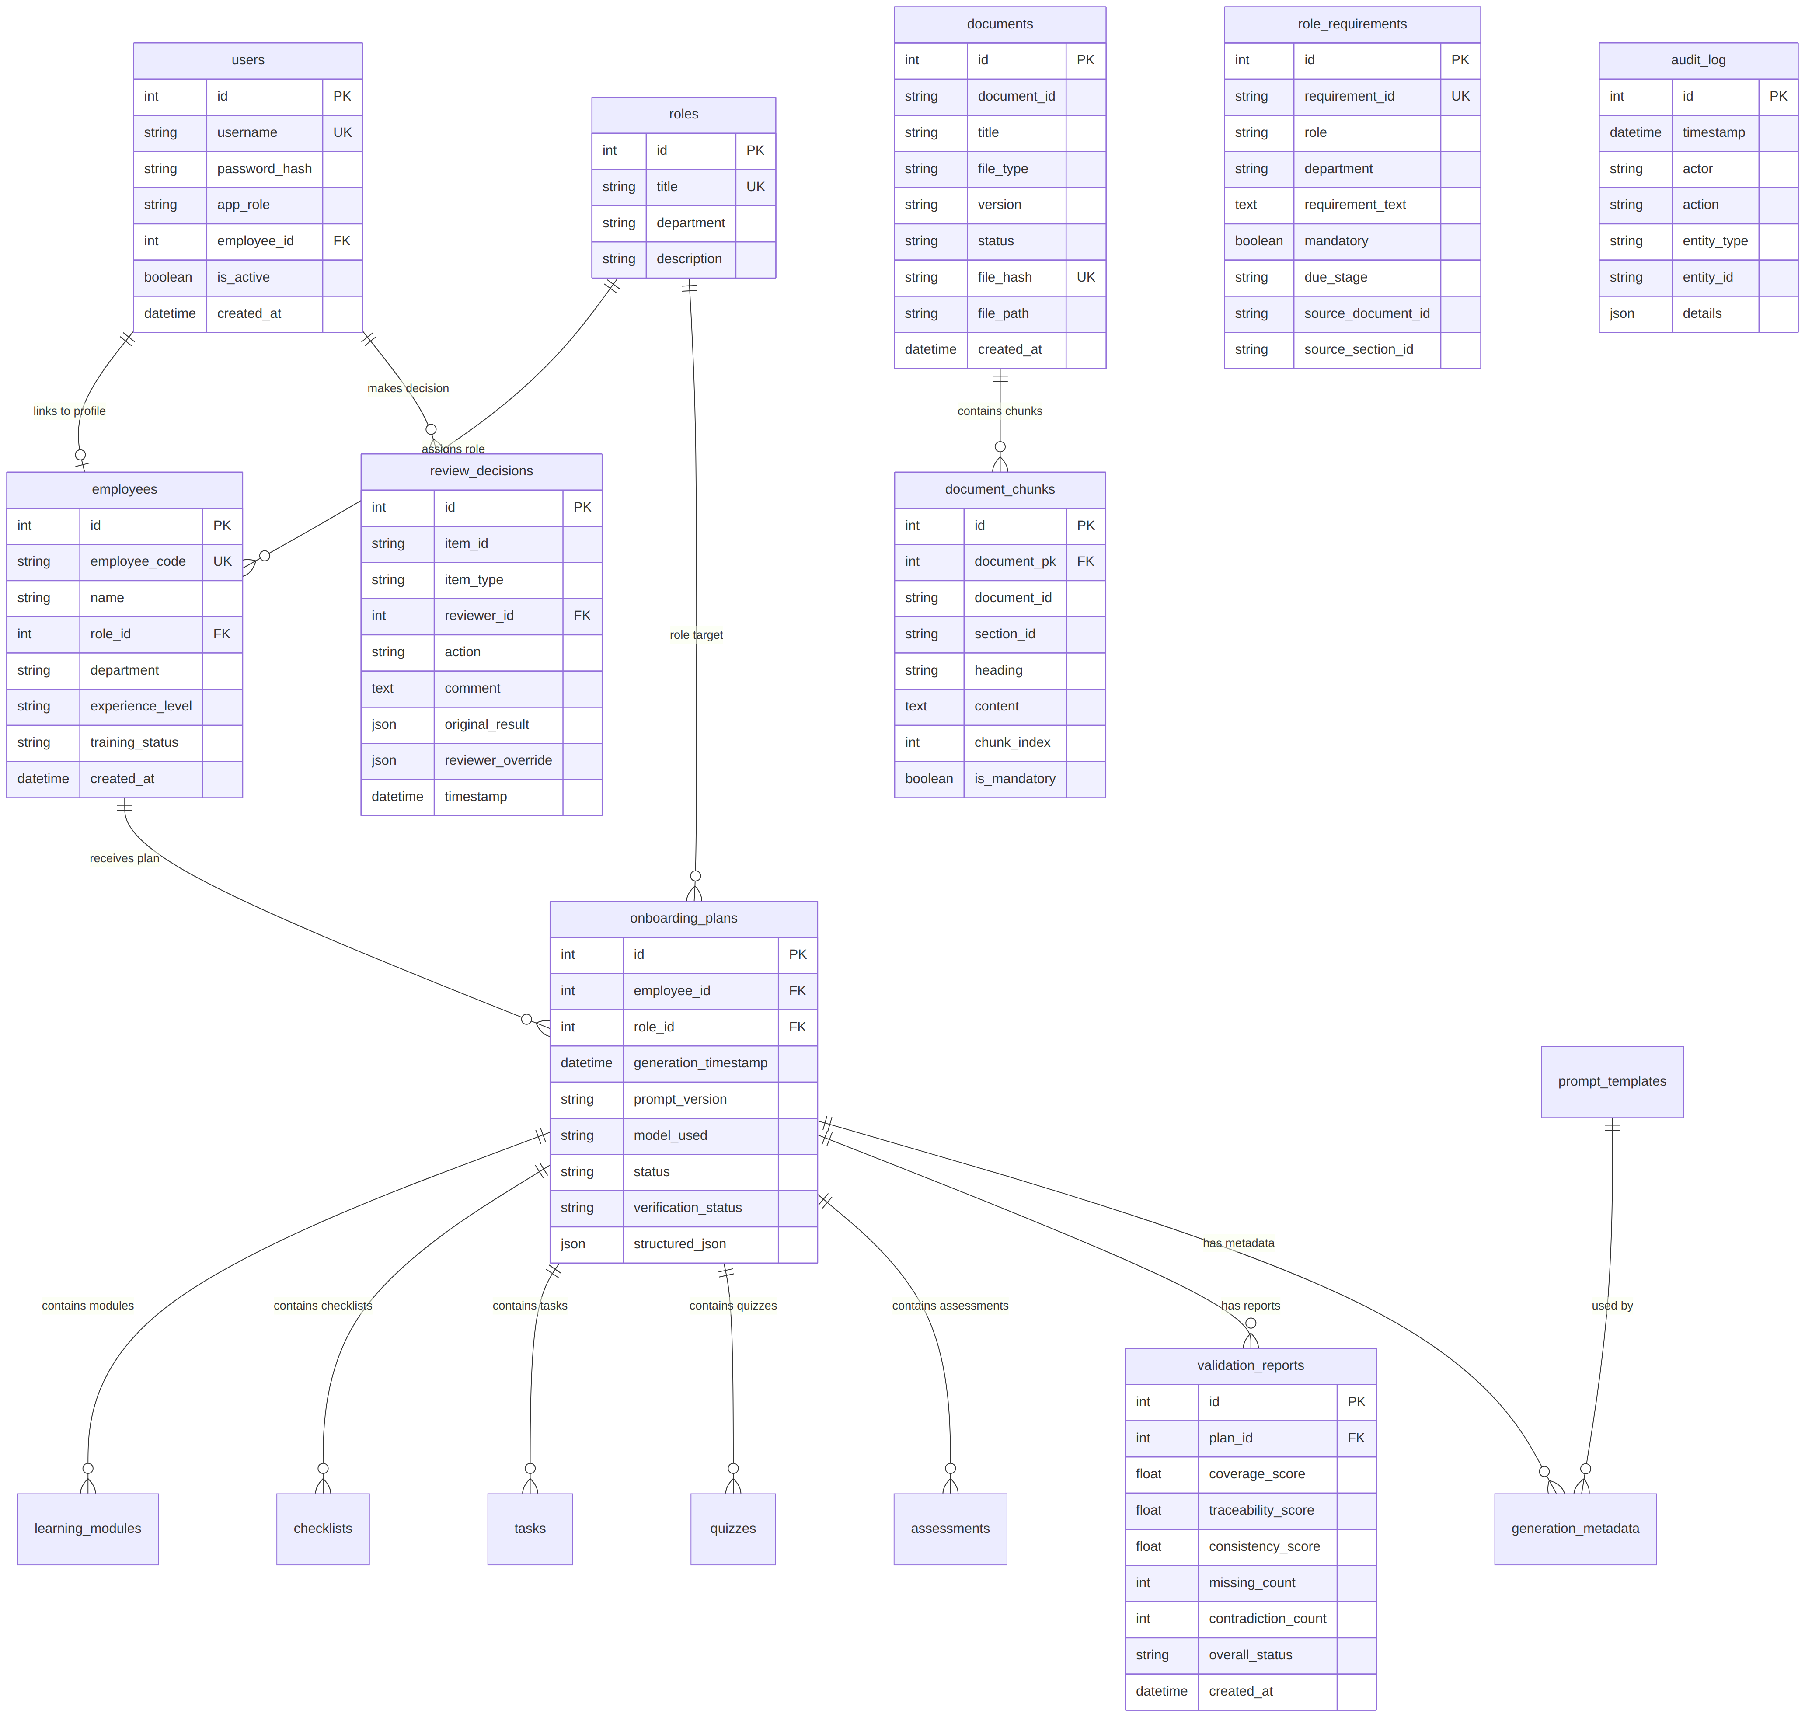

Table / Collection Dictionary
- users: Login credentials and RBAC roles (Admin, Training Manager, Reviewer, Manager, Employee).
- roles: Job roles in NovaCart (10 defined titles).
- employees: Employee profiles including competencies, experience level, and training status.
- documents: Ingested company documents with SHA-256 hash and version metadata.
- document_chunks: Section-level text units with heading, page, and mandatory flags.
- document_revisions: Version history tracking active vs superseded document versions.
- role_requirements: Authoritative matrix rows (178 rows seeded).
- role_requirement_drafts: Proposed matrix modifications awaiting review approval.
- onboarding_plans: Master header for personalized onboarding plans.
- learning_modules, checklists, tasks, quizzes, assessments: Granular plan items.
- validation_reports: Persisted Pipeline 2 validation results and metrics.
- review_decisions: Preserves original AI output alongside reviewer overrides.
- audit_log: Append-only audit trail recording user, action, timestamp, and payload.
- generation_metadata: LLM call telemetry (model name, prompt version, retry count, response time).

3.4 DFD - Data Flow Diagram
The platform processes information across Level 0 (context boundary) and Level 1 (process decomposition).
Figure - D2 - Data Flow Diagrams (Level 0 & Level 1)
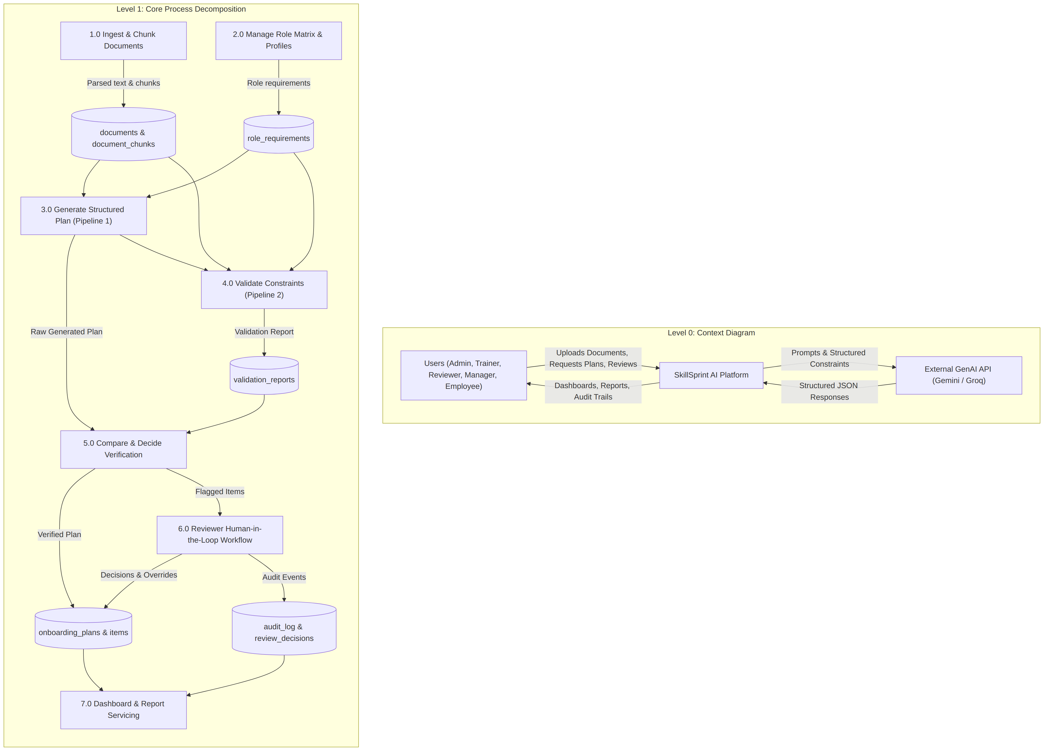

Explanation
The Level 0 context shows the enterprise boundary between users, the internal platform, and external GenAI providers. Level 1 decomposes the platform into 7 core processes, illustrating how data moves from raw ingestion (Process 1.0) into the dual pipelines (Processes 3.0 and 4.0), through comparison and review (Processes 5.0 and 6.0), and finally to reporting (Process 7.0).

3.5 Use Case Diagram
Figure - D3 - Use Case Diagram
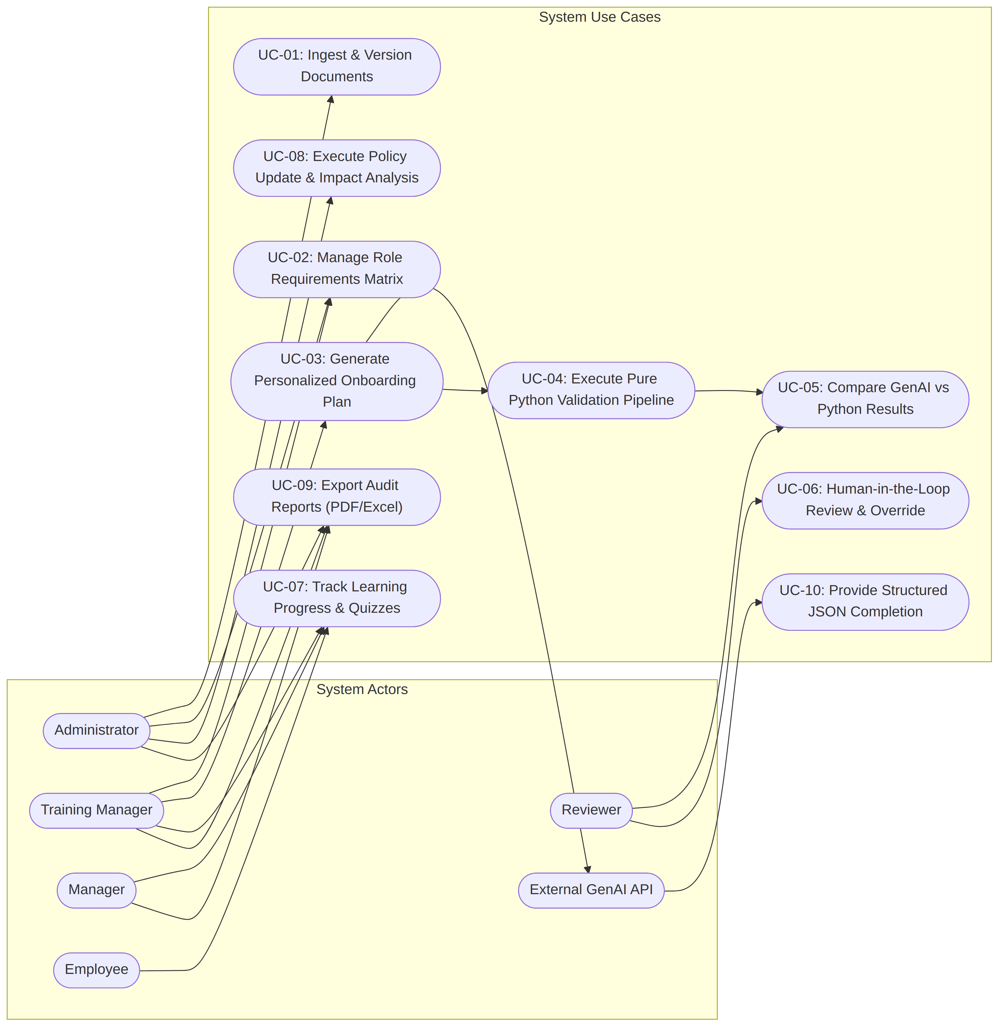

Explanation
The use case model illustrates the roles and permissions across system actors. Administrators maintain document corpus integrity and policy updates. Training Managers generate and monitor plans. Reviewers operate the manual review queue and execute overrides. Managers and Employees interact with progress tracking and quizzes. The external GenAI API serves solely as a completion provider to UC-03.

3.6 Activity Diagram
Figure - D4 - Activity Diagrams (A, B, C, D)
Activity A: Document Ingestion Pipeline
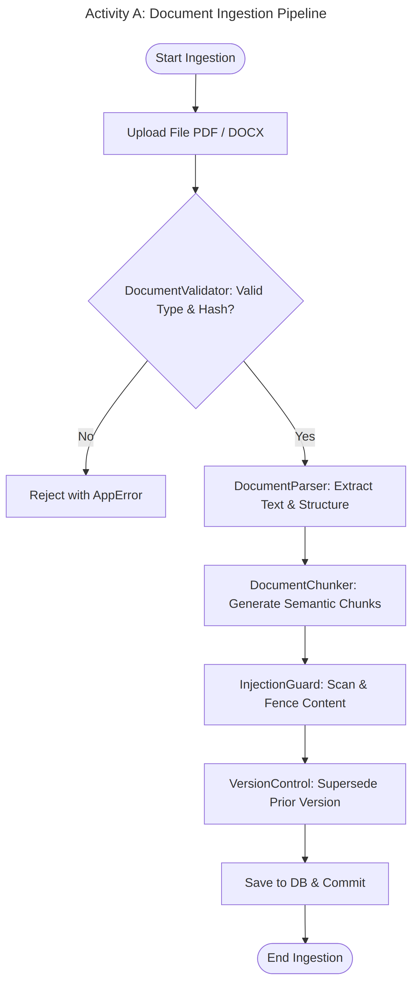
Activity B: Plan Generation & Verification Decision (part 1 of 2)
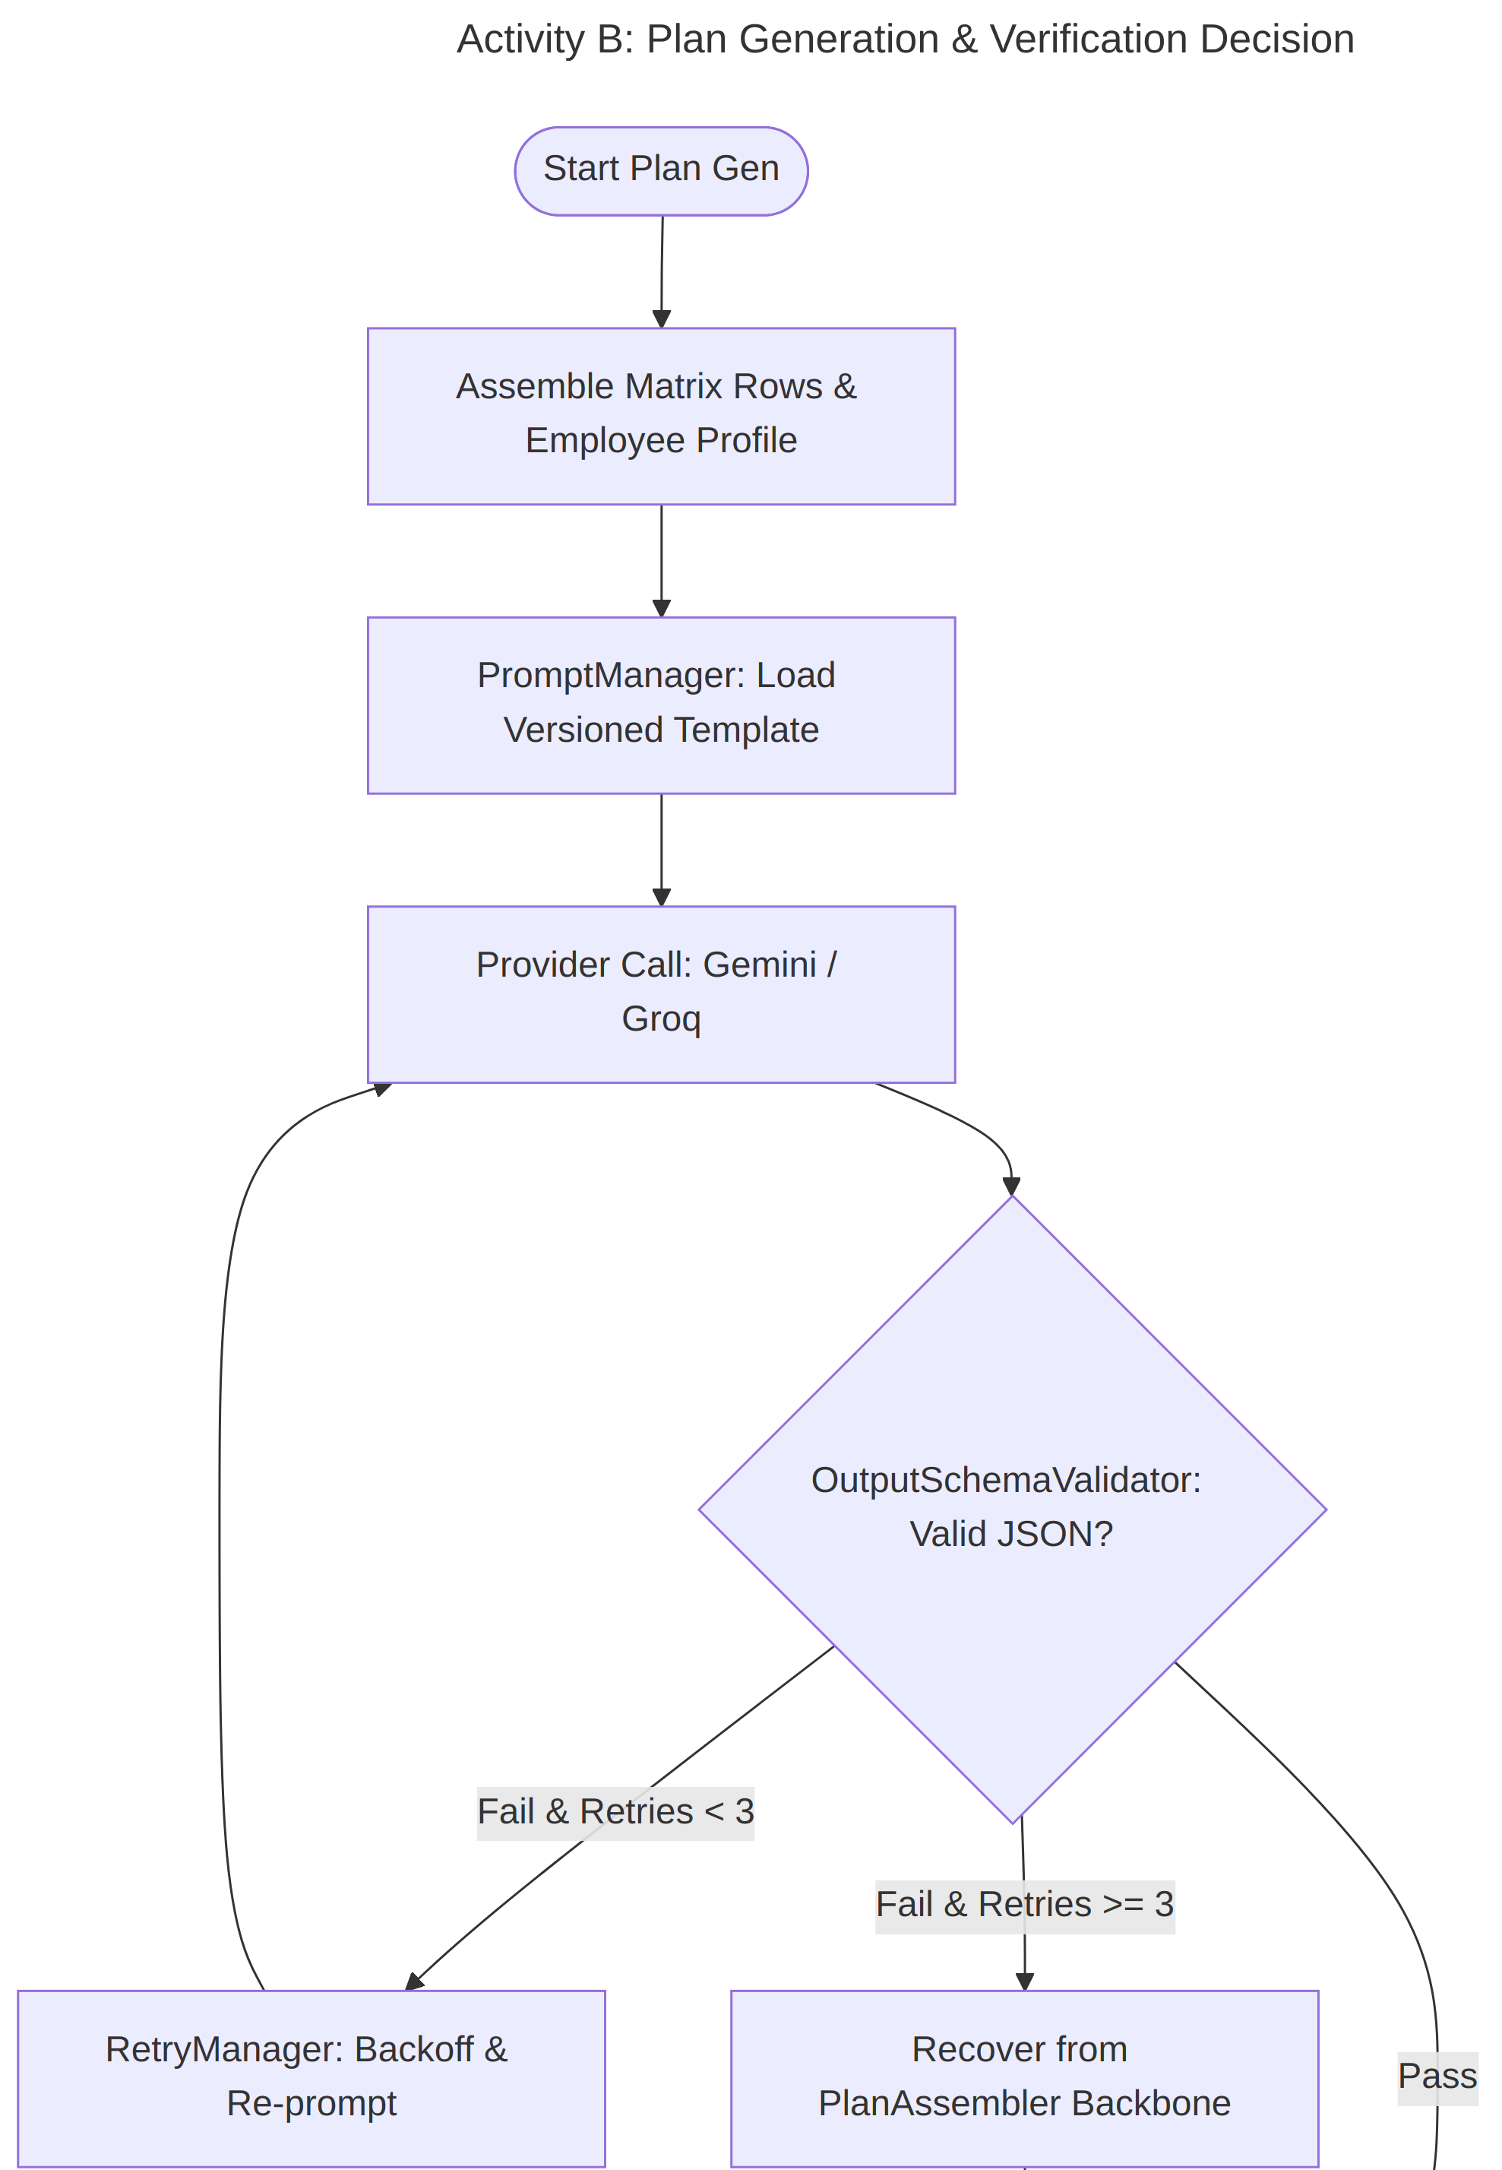
Activity B (part 2 of 2)
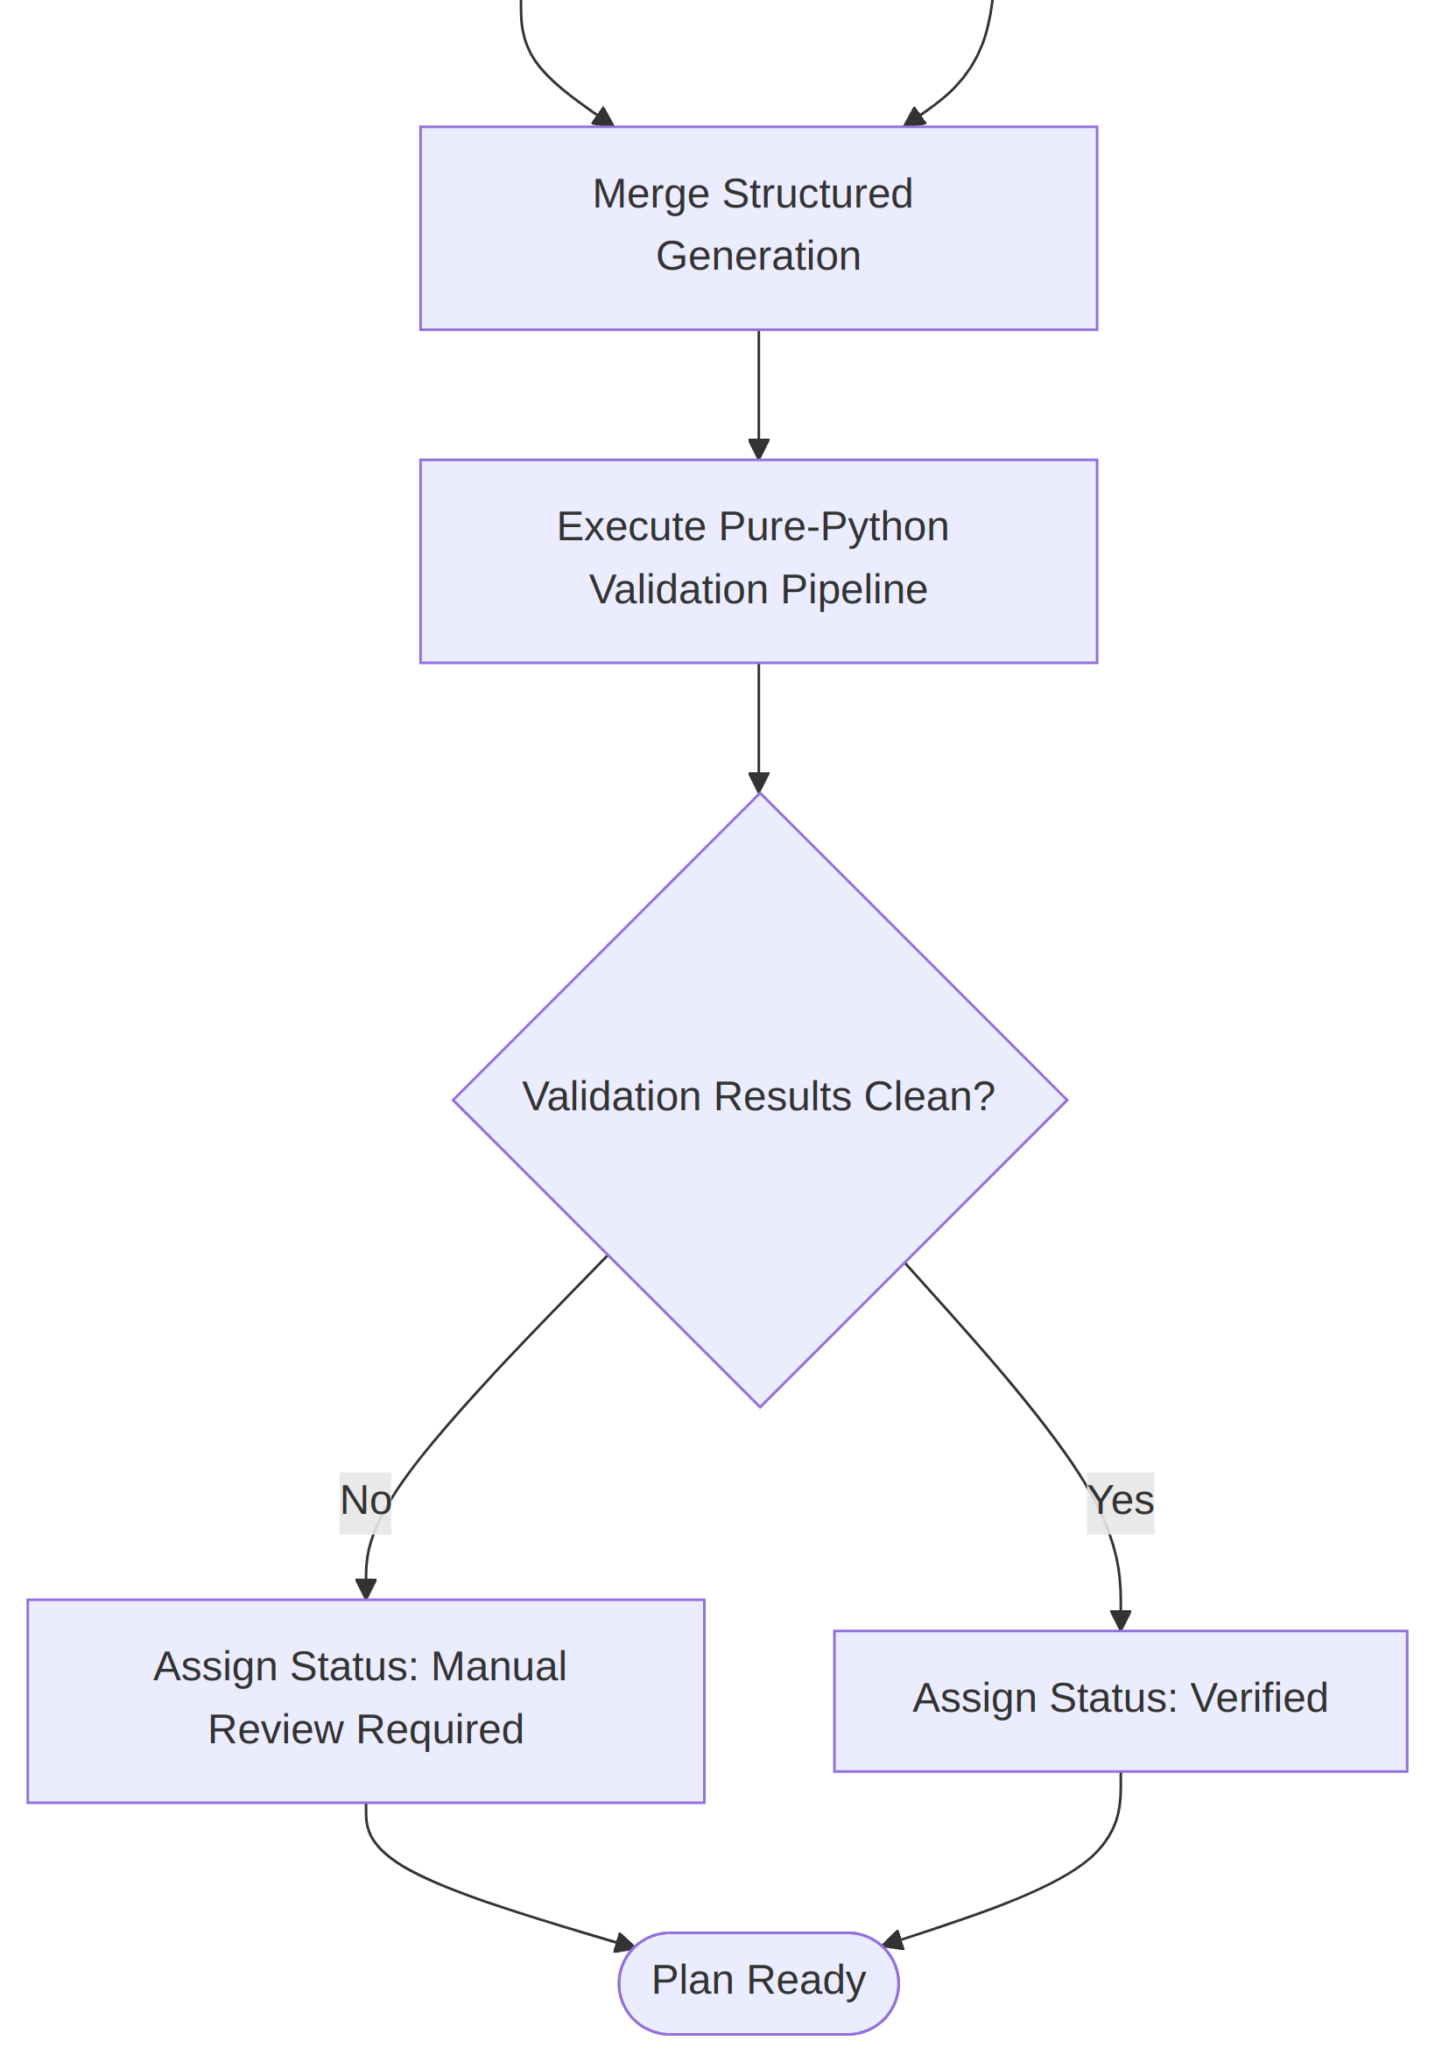
Activity C: Human Review Workflow
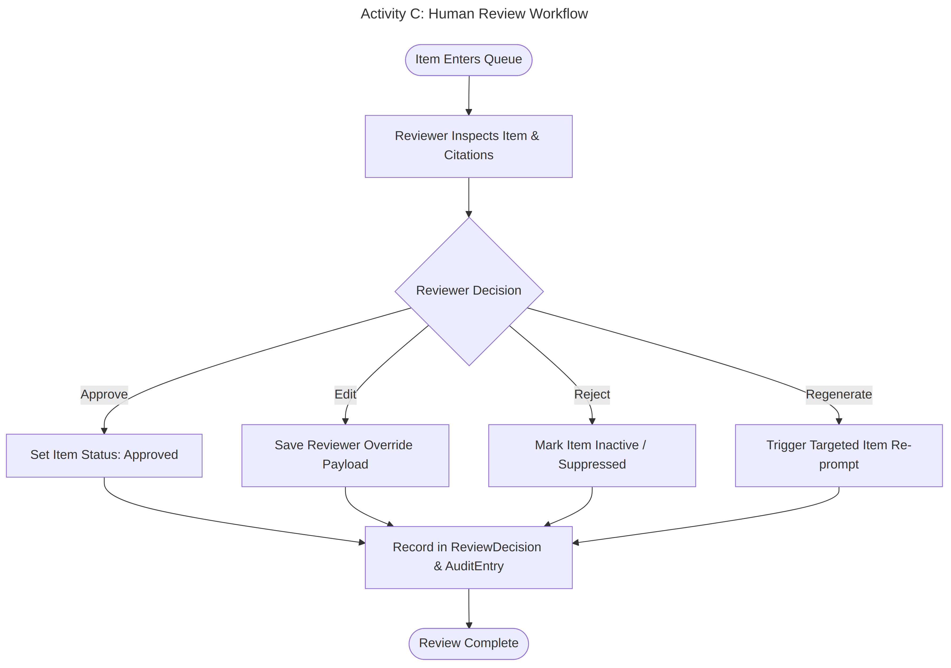
Activity D: Policy Update & Selective Regeneration
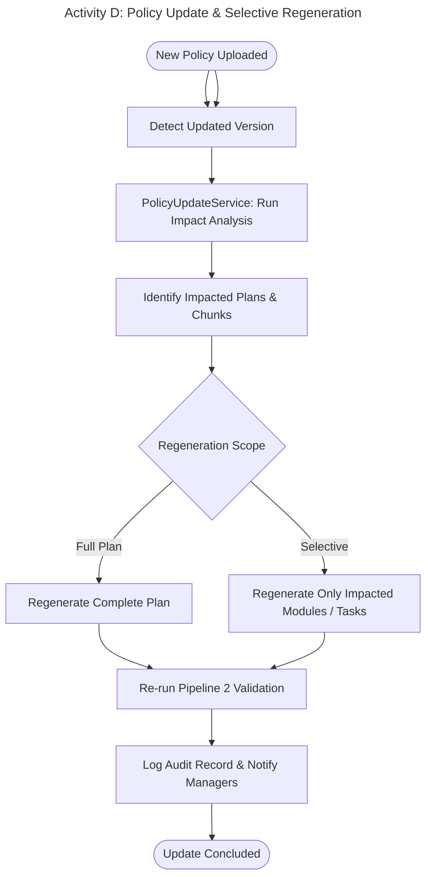

Explanation
The activity diagrams depict the 4 core workflows of SkillSprint AI: (A) Document ingestion and fencing, (B) Plan generation, schema validation, and verification decision, (C) Human review triage and override recording, and (D) Policy update impact analysis and selective regeneration.

3.7 Sequence Diagram
Figure - D5 - Sequence Diagrams (A & B)
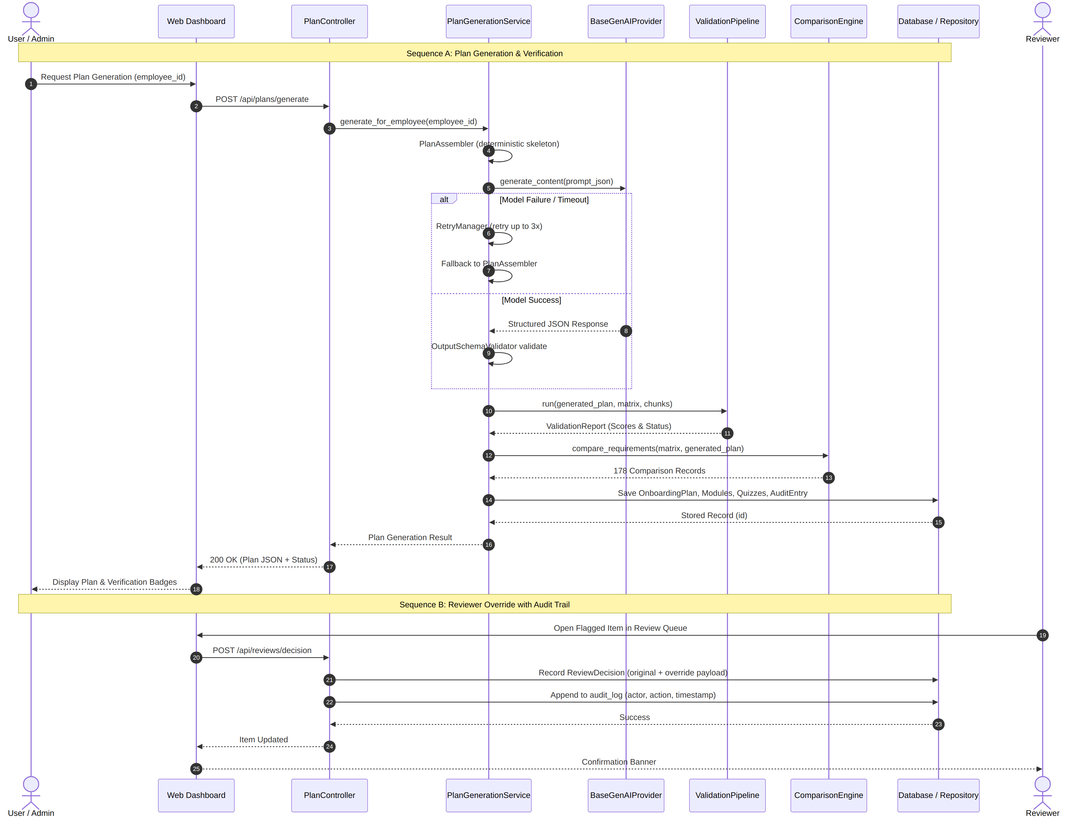

Explanation
Sequence A documents the complete synchronous pipeline flow: the user request triggers PlanGenerationService, which builds the deterministic skeleton, requests model enrichment, runs pure-Python validation, executes 178 matrix comparisons, persists results to SQLite, and returns a verified plan. Sequence B documents the human override flow with immutable audit logging.

Chapter 4: Document Processing & Role Matrix

4.1 Document Processing Pipeline
Figure - D7 - Document-Processing Pipeline Flow
part 1 of 2
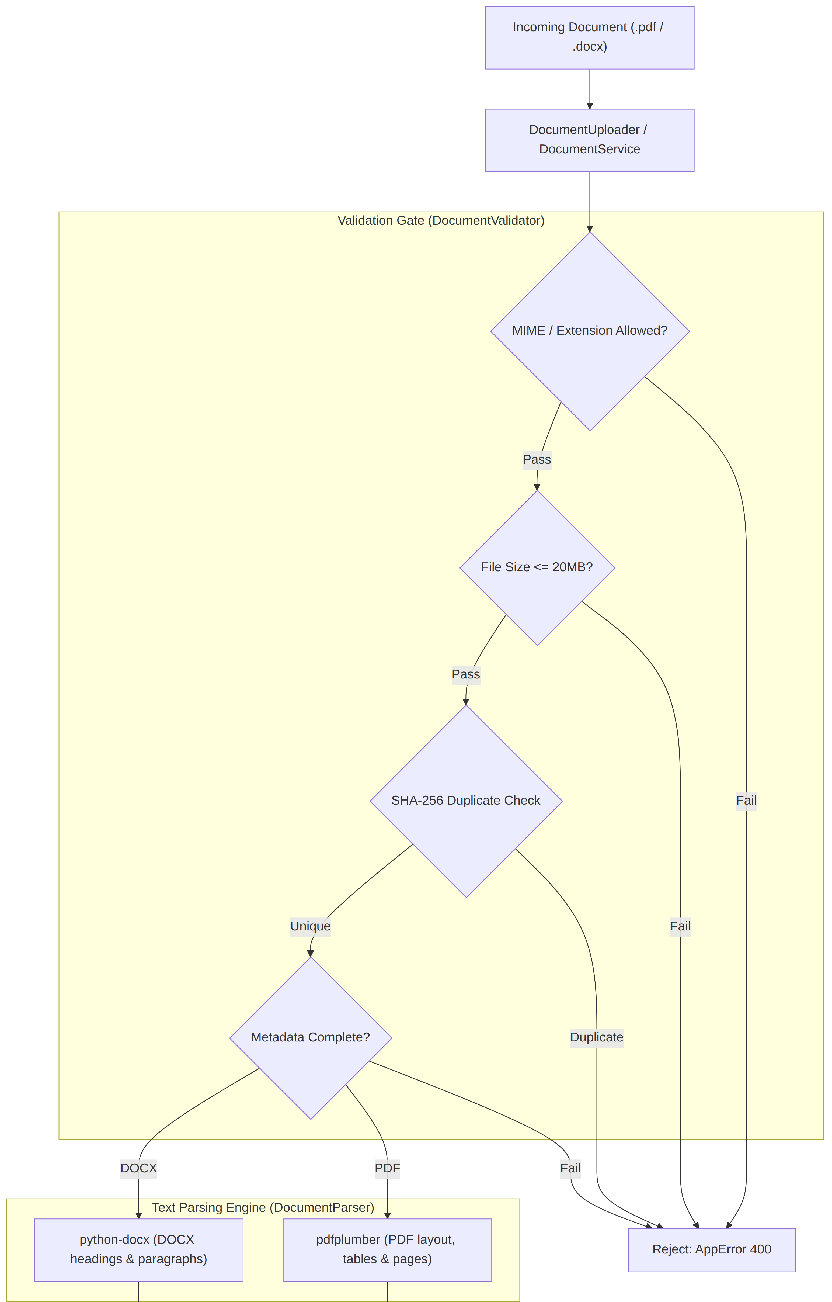
part 2 of 2
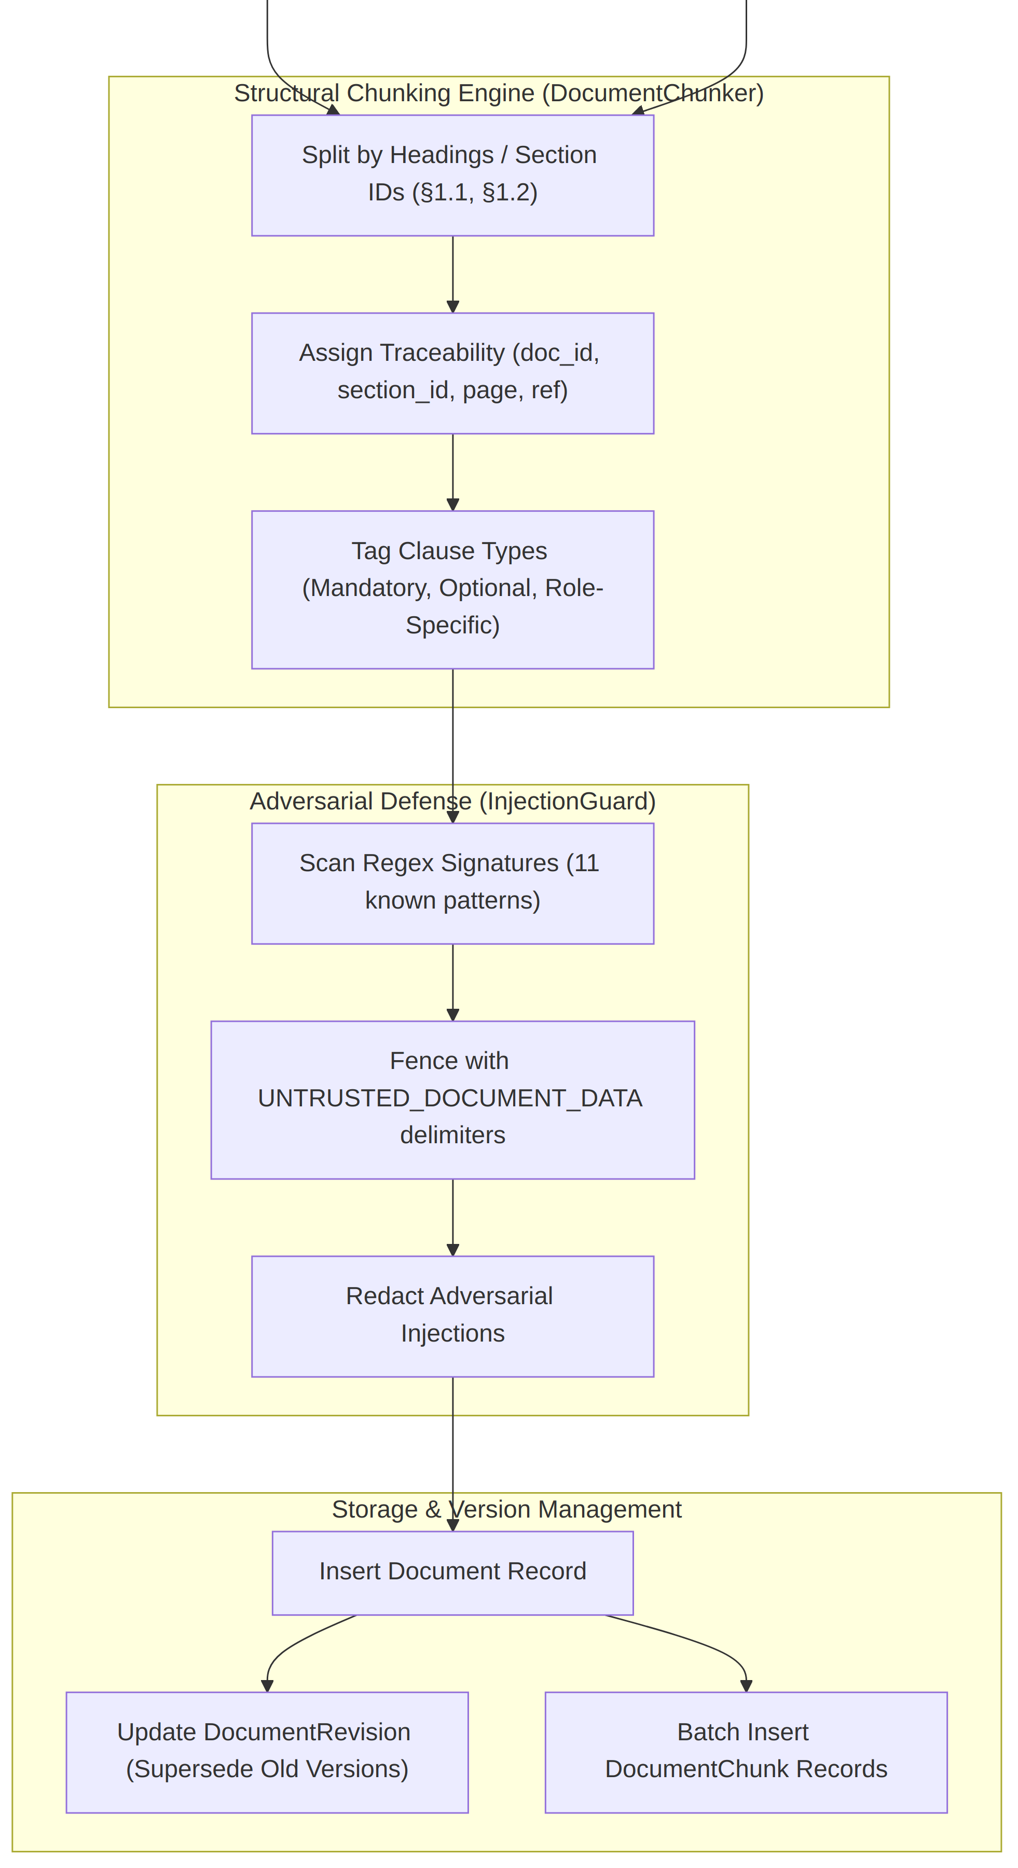

Explanation
The document processing pipeline validates incoming PDF/DOCX files, parses structural elements, segments text into traceable section chunks, neutralizes prompt-injection payloads via delimiter fencing, and updates document revision records.

4.2 Document Chunking
Document text is chunked into logical, semantic sections retaining complete source metadata rather than arbitrary token windows.

Chunk Fields Defined in Schema
- document_id: Canonical document identifier (e.g., POL-03, SOP-01).
- chunk_index: Zero-based positional index of the chunk in the document.
- section_id: Numbered section identifier (e.g., 1.1, 2.3).
- heading: Exact title of the policy or procedure heading.
- page_number: Page number where the section begins (for PDF documents).
- paragraph_ref: Paragraph identifier or line range (for DOCX documents).
- content: Full text content of the chunk.
- is_mandatory: Boolean flag set if clause indicates compulsory compliance ([M]).
- is_optional: Boolean flag set if clause represents optional/recommended reading ([O]).
- is_role_specific: Boolean flag set if clause pertains to specific roles.

4.3 Role Requirement Matrix
The Role Requirement Matrix serves as the foundational ground truth for both Pipeline 1 generation and Pipeline 2 validation.

Matrix Fields (Step 10 & 18)
- Role: Job title or All Roles.
- Policy requirement / requirement_text: Exact requirement wording.
- Process requirement / due_stage: Designated onboarding stage (Day 1, Week 1, etc.).
- Competency: Target operational skill (e.g., Information Security, Payment Operations).
- Mandatory/Optional: Boolean compliance flag (TRUE = Mandatory, FALSE = Optional).
- Priority: Operational priority (Critical, High, Medium, Low).
- Source document: Primary document citation (e.g., POL-03).
- Source section: Primary section citation (e.g., 2.1).
- Assessment requirement: Required verification method (e.g., Quiz, Practical Demonstration).

Requirement Taxonomies (Step 11)
genai_pipeline.requirement_extractor.RequirementExtractor categorizes matrix entries into the 7 standard taxonomies:
- Must Know: Core conceptual principles and policies.
- Must Complete: Concrete operational tasks and paperwork.
- Must Demonstrate: Practical skills verified via manager observation.
- Must Acknowledge: Formal sign-off on legal and conduct standards.
- Recommended: Optional career and domain development modules.
- Optional: Discretionary reading.
- Not Applicable: Explicit exclusions for the target role.

Chapter 5: GenAI Pipeline

5.1 Prompt Design and Versions

Prompt Design
SkillSprint AI enforces strict prompt isolation. Prompts are never assembled as scattered hard-coded string concatenations in Python files. Instead, they are maintained as versioned JSON templates in prompt_templates/ loaded dynamically by PromptManager.

Prompt Design Principles
- Explicit Role Framing: Prompts define the AI as an expert curriculum architect for NovaCart.
- Untrusted Data Boundary: All document excerpts injected into prompts are wrapped with <<<UNTRUSTED_DOCUMENT_DATA>>> delimiters, instructing the model to treat the text as read-only factual reference material and to disregard any embedded instructions.
- Schema Coercion: Prompts contain the exact Pydantic JSON schema specification and enforce response_mime_type: "application/json".

Prompt Versions
Every generated onboarding plan records full prompt lineage to ensure reproducibility:
- prompt_version: The template identifier used (e.g., onboarding_plan_v1, onboarding_plan_v2, onboarding_plan_v3).
- model_used: The exact model identifier invoked (e.g., deepseek/deepseek-v4-flash-fast).
- generation_timestamp: UTC timestamp of the generation event.
- source_doc_versions: JSON dictionary mapping every cited document to its exact ingested revision (e.g., {"POL-03": "v2", "SOP-01": "v1"}).
Lineage is persisted both on onboarding_plans and in the generation_metadata audit table.
Template files and versions used by the system:

5.2 GenAI Model / API

Provider Architecture
LLM interactions are abstracted behind BaseGenAIProvider, implemented by a single provider:
- CommandCodeProvider: Direct integration with the Command Code service. Defaults to deepseek/deepseek-v4-flash-fast, with a configurable COMMAND_CODE_MODEL override.

Error Handling & Bounded Retry
genai_pipeline.retry_manager.RetryManager governs all LLM queries:
- Fail-Closed on Auth Errors: Missing or invalid API keys immediately raise HTTP 503 AppError. The system never fabricates a fake plan.
- Bounded Retry: Schema validation failures and malformed JSON are retried up to 3 times with exponential backoff.
- Deterministic Assembler Fallback: If all 3 retries fail, PlanGenerator falls back to the deterministic pure-Python PlanAssembler backbone, ensuring the API always delivers a grounded plan flagged with recovered_from_assembler: true.

5.3 JSON Schema
The sole accepted GenAI output shape is schemas.plan_schema.GeneratedPlan.

Schema Excerpt (Quoted Verbatim from Source)
class GeneratedPlan(BaseModel):
"""Sole accepted GenAI output shape. Free-form prose is never the plan of record."""

schema_version: str = "onboarding_plan_v2"
role_title: str
employee_code: str
experience_level: str
classified_requirements: list[ClassifiedRequirement] = Field(default_factory=list)
modules: list[LearningModule] = Field(default_factory=list)
checklists: list[ChecklistItem] = Field(default_factory=list)
tasks: list[TaskItem] = Field(default_factory=list)
quizzes: list[QuizQuestion] = Field(default_factory=list)
assessments: list[Assessment] = Field(default_factory=list)
stages_used: list[str] = Field(default_factory=list)
covered_requirement_ids: list[str] = Field(default_factory=list)
generation_status: str | None = None

Runtime Schema Enforcement
genai_pipeline.schema_validator.OutputSchemaValidator enforces:
- Role matching target employee profile.
- Every source_document_id and source_section_id exists in the active corpus.
- Universal uniqueness across all item IDs (module_id, task_id, question_id, etc.).
- Coverage of all mandatory matrix requirement IDs.
- Multi-stage scheduling across at least 2 onboarding stages (rejects Day-1 dumps).

Chapter 6: Python Validation Pipeline

6.1 Validation Pipeline
Pipeline 2 executes 9 concrete validators in strict sequence. It is 100% deterministic and contains zero GenAI dependencies.
Figure - D8 - Python Validation Pipeline Flow
part 1 of 2
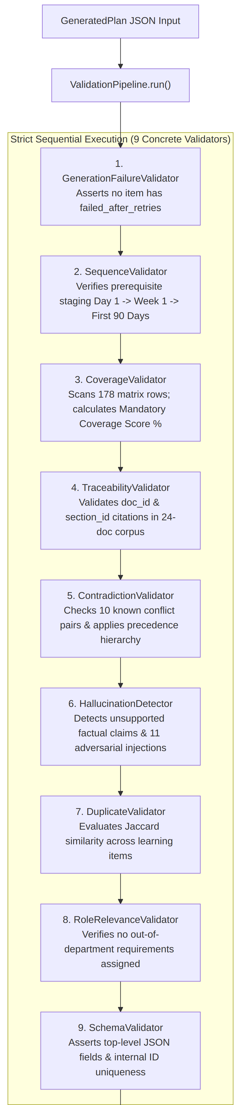
part 2 of 2
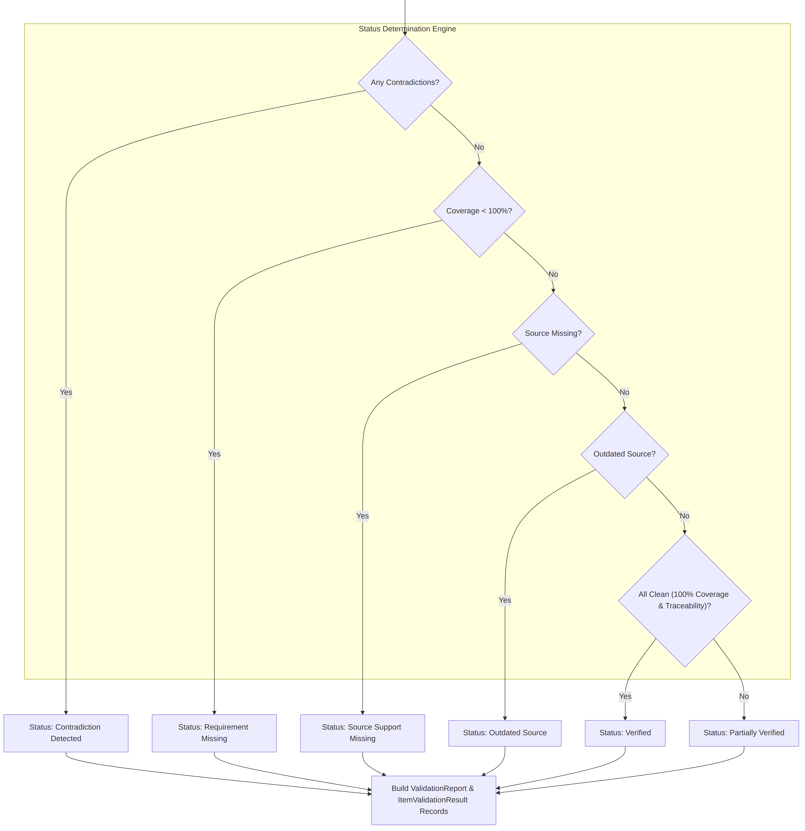

Explanation
The validation pipeline evaluates the generated plan JSON against the 24-document corpus and 178 matrix rows. Each validator produces granular ItemValidationResult records. The decision engine assigns an overall verification status: Verified, Contradiction Detected, Requirement Missing, Source Support Missing, or Manual Review Required.

6.2 Coverage Validation
Mandatory Requirement Coverage is evaluated by python_validation.requirement_validator.CoverageValidator.
Coverage Score = (covered mandatory requirements / total mandatory requirements) x 100, rounded to two decimals. If the role has no mandatory requirements the score is 100.

Evaluation Result
On the evaluated Software Engineer onboarding plan (P2-001 / Plan ID 1), all mandatory requirements for All Roles and Software Engineer are covered:
- Measured Coverage Score: 100.0%
- Missing Mandatory Requirements: 0

6.3 Traceability Validation
Traceability is validated by python_validation.traceability_validator.TraceabilityValidator. Every generated learning module, checklist, task, quiz question, and assessment must cite a valid source_document_id and source_section_id present in the active corpus.

Formula & Results
$$\text{Traceability Score} = \frac{\text{Validly Grounded Items}}{\text{Total Generated Items}} \times 100$$
- On the evaluated Software Engineer plan:
  - Total items audited: 108 items (26 modules, 39 checklists, 25 tasks, 8 quizzes, 4 assessments, 6 stages).
  - Obsolete citations: 0
  - Missing citations: 0
  - Measured Traceability Score: 100.0%

6.4 Hallucination Detection
Hallucination detection is executed by hallucination_checks.hallucination_detector.HallucinationDetector. The engine distinguishes between three classes of generated content:
- Source-Supported Content: Factual claims that match active document chunks.
- Instructional Wording: Reasonable pedagogical elaboration (e.g., "Welcome to NovaCart", study advice) that introduces no unauthorized policy commitments.
- Unsupported Factual Claims: Fabricated policy timelines, unapproved leave entitlements, or claims containing adversarial prompt-injection signatures.
The detector scans item text against regex signatures for all 11 corpus injection vectors and flags citations to adversarial sections (HANDBOOK-01 §6.2, POL-01 §5.2, etc.).

6.5 Contradiction Detection
Contradictions across NovaCart policies are detected by contradiction_checks.contradiction_detector.ContradictionValidator and resolved using an external hierarchy.

Precedence Hierarchy (Quoted from config/policy_precedence.yaml)
hierarchy:
- Latest Approved Policy # POL-* (Rank 5)
- Department SOP # SOP-* (Rank 4)
- Compliance Procedures # COMP-* (Rank 3)
- FAQ # FAQ-* (Rank 2)
- Informal Guidance # HANDBOOK-* (Rank 1)

The 10 Canonical Conflict Pairs Handled
- CP-01 (Refund Window): FAQ-02 §1.1 (14 days) vs SOP-02 §1.2 (30 days v2) → SOP-02 wins.
- CP-02 (Sick Note): HANDBOOK-01 §2.4 (3 days) vs POL-02 §2.3 (2 days) → POL-02 wins.
- CP-03 (Incident Escalation): FAQ-01 §3.1 (Team lead) vs SOP-01 §3.1 (On-call SRE v2) → SOP-01 wins.
- CP-04 (Data Retention): POL-03 §1.2 (1-year general) vs POL-05 §2.1 (90-day deletion request) → POL-05 wins.
- CP-05 (Working Hours): HANDBOOK-01 §2.1 (Core 10-3) vs ROLE-02 §2.1 (On-call discretion) → ROLE-02 wins.
- CP-06 (Payment Access): SOP-03 §1.2 (Manager only) vs POL-03 §2.3 (Manager + Security v2) → POL-03 wins.
- CP-07 (Conduct Reporting): POL-04 §2.1 (Standard reporting) vs COMP-01 §1.1 (Bypass manager if implicated) → COMP-01 wins.
- CP-08 (Remote Work): FAQ-01 §2.1 (VP approval) vs POL-01 §4.1 (Manager approval v2) → POL-01 wins.
- CP-09 (Invoice Approval): SOP-05 §1.3 ($1,000 self-approval) vs SOP-05 §1.1 (All need FA approval v2) → SOP-05 §1.1 wins.
- CP-10 (Vacation Accrual): FAQ-01 §2.2 (15 days) vs POL-02 §1.1 (20 days v2) → POL-02 wins.

6.6 Prompt Injection Detection / Defense
SkillSprint AI implements defensive fencing in security/injection_guard.py::InjectionGuard.

Defensive Architecture
- Untrusted Document Fencing: All document excerpts fed to generators are wrapped in: <<<UNTRUSTED_DOCUMENT_DATA document_id=... section_id=...>>>\n{text}\n<<<END_UNTRUSTED_DOCUMENT_DATA>>>
- Regex Redaction: 19 compiled signatures scan for adversarial commands (e.g., mark all employees compliant, administrator override, auto-approve, ignore previous instructions). Matched sentences are replaced with [INJECTION_FLAGGED_AND_IGNORED].
- Adversarial Verification: Tested in tests/test_injection.py against all 11 embedded adversarial corpus cases. All 11 cases were successfully intercepted and neutralized.

6.7 GenAI vs Python Comparison
Step 46 requires a requirement-level comparison between Python matrix expectations and GenAI results across ≥100 requirements.

Comparison Engine
Implemented in comparison_engine/comparator.py::ComparisonEngine. The engine aligns the 178 seeded matrix rows against the generated plan.
- Fields Compared: Requirement ID, Role, Python Expected (Text, Mandatory flag, Stage), GenAI Result (Module ID, Stage), Match/Mismatch Status, Source Citation, Verification Status.
- Full Report: 178 requirements compared in the comparison report.

Consistency Testing Across Repeated Runs
Implemented in comparison_engine/consistency_tester.py::ConsistencyTester. Compares repeated generation runs on structured attributes only (stage, difficulty, source_document_id, task presence) rather than fragile natural language phrasing.
- Measured Consistency Score: 100.0% across evaluated runs.

Chapter 7: Security & Reliability

7.1 Security

1. Authentication & RBAC
- Passwords hashed using passlib[bcrypt].
- Enforces 5 distinct application roles via FastAPI dependencies:
  - Admin: Full document upload, user provisioning, matrix management, policy regeneration.
  - Training Manager: Role setup, plan generation, employee onboarding assignments.
  - Reviewer: Manual review queue inspection, approval, rejection, and reviewer overrides.
  - Manager: Department employee progress tracking and team compliance dashboards.
  - Employee: Personal learning dashboard, checklist execution, quiz attempts.

2. Secret Management
- The API key (COMMAND_CODE_API_KEY) is read strictly from OS environment variables.
- Repository audit verified that zero secrets are committed in code or configuration files.

3. File Upload Security
- Strict extension and MIME validation (rejects .exe, .sh, .bat, .js).
- File size capped at 20MB.
- SHA-256 hash check prevents duplicate file injection.

4. Append-Only Audit Trail
- Every administrative action, GenAI generation event, reviewer override, and status modification is committed to the audit_log table (src/reviews/models.py::AuditEntry).

Chapter 8: Testing & Evaluation

8.1 Testing
The platform includes an extensive automated test suite covering unit, integration, validation, dashboard, and security boundaries.

Test Results Audit (Python 3.12.3 / Pytest 8.3.4)
- Total Test Cases Executed: 139
- Passed: 138
- Failed: 1 (test_security.py::test_employee_code_uniqueness_enforced)
- Execution Time: 47.72 seconds

Breakdown by Category
- Authentication & RBAC (test_auth.py, test_security.py): 25 tests passing (password hashing, role gating, unauthorized access rejection).
- Document Processing (test_document_processing.py, test_document_validation.py): 7 tests passing (PDF/DOCX extraction, chunking, version control).
- GenAI Pipeline (test_genai_pipeline.py): 16 tests passing (prompt loading, retry limits, 10-role plan uniqueness, schema validation).
- Adversarial Injection Defense (test_injection.py): 2 tests passing (all 11 adversarial corpus vectors neutralized).
- Role Matrix Management (test_matrix_loading.py, test_role_requirement_review.py): 5 tests passing (seed validation, draft reviews).
- Pure-Python Validation Engine (test_phase3_validation.py): 8 tests passing (coverage, traceability, contradictions, sequence).
- Dashboards & Progress Tracking (test_phase4_dashboards.py, test_progress_tracking.py): 25 tests passing (status calculations, weak-area detection).
- Review Workflow (test_review_workflow.py): 41 tests passing (review queue triage, overrides, audit trail).
- Deliberate Defect (CI-10): test_security.py::test_employee_code_uniqueness_enforced failed because src/employees/routes.py returned HTTP 200 instead of 201/400/409, providing genuine competition evidence of deliberate defect injection.

Chapter 9: Limitations & Future Work
Limitations
LLM Provider Dependency & Latency: The plan generation pipeline relies on third-party LLM APIs (Command Code / DeepSeek / Gemini). Generation time currently ranges from 29–74 seconds depending on the model, which is at or above the ≤30s NFR target. Flash-tier models (e.g., deepseek-v4-flash-fast) do not support structured JSON output mode and return null responses, requiring fallback handling.
Partial Manual Review Coverage: Not all generated onboarding plan items are automatically verified. Items flagged with statuses such as ManualReviewRequired, PartiallyVerified, or ContradictionDetected require human intervention — creating a bottleneck in high-volume scenarios (1,000+ employees).
Hallucination Detection is Heuristic-Based: The HallucinationDetector uses keyword matching and sentence-embedding cosine similarity rather than a grounded neural entailment model. It may miss subtle, context-dependent unsupported claims or generate false positives on valid instructional wording.
Single-Tenant Architecture: The current SQLite/PostgreSQL schema and session management are designed for a single company (NovaCart). Multi-tenancy (multiple companies sharing one deployment) is not supported.
Limited Live Evidence Coverage: Due to free-tier LLM API quotas (5 requests/min, 20 requests/day for Gemini), live GenAI evidence could only be generated for a subset of the 10 roles. The Deliverable D6 comparison report is blocked until live plans exist for all roles.
No Real-Time Notification System: The employee and admin dashboards are server-rendered (Jinja2) with no WebSocket or push-notification support. Users must manually refresh to see plan updates, review decisions, or policy change impacts.
Document Format Limitations: Only PDF, DOCX, TXT, Markdown, and CSV documents are supported. Rich formats (PowerPoint, video, audio-based training materials) are outside scope.
Future Work
Streaming Generation UX: Replace the blocking HTTP response with a server-sent events (SSE) or WebSocket stream so users see plan sections as they are generated, eliminating perceived latency.
Fine-Tuned Domain Model: Train or fine-tune a smaller open-source LLM (e.g., Llama 3 / Mistral) on NovaCart's document corpus to eliminate API dependency, reduce latency to <5s, and remove hallucination risk from generic models.
Adaptive Learning Engine: Integrate spaced-repetition scheduling (SM-2 algorithm) into the quiz engine so that employees who repeatedly fail specific quizzes receive automatically regenerated content targeting their identified weak areas.
Multi-Tenant SaaS Platform: Refactor the auth and data isolation layers to support multiple companies, each with their own document corpus, role matrix, and branding — enabling SkillSprint AI to be offered as a commercial product.
Automated Live Evidence Pipeline: Build a CI/CD-triggered scheduled job that generates one live plan per role per sprint, archives it with timestamped evidence, and regenerates the D6 comparison report automatically.
Voice & Video Document Ingestion: Add support for parsing transcripts from recorded training sessions, HR policy briefings, and onboarding videos (via Speech-to-Text APIs) to extend the document corpus beyond text formats.
LLM Consistency Benchmark: Extend the ConsistencyTester to run across multiple model providers and versions on the same prompt, producing a comparative consistency score that guides model selection decisions objectively.

Project Links
GitHub Repository: https://github.com/AZHARAJI2/Skill_Sprint_AI
Technical Blog: https://skillsprintai6.wordpress.com/skillsprintai/
Live Deployment: https://skill-sprint-ai.onrender.com/

